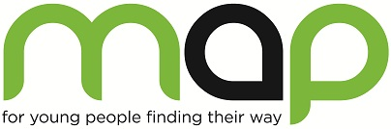**Welcome to**

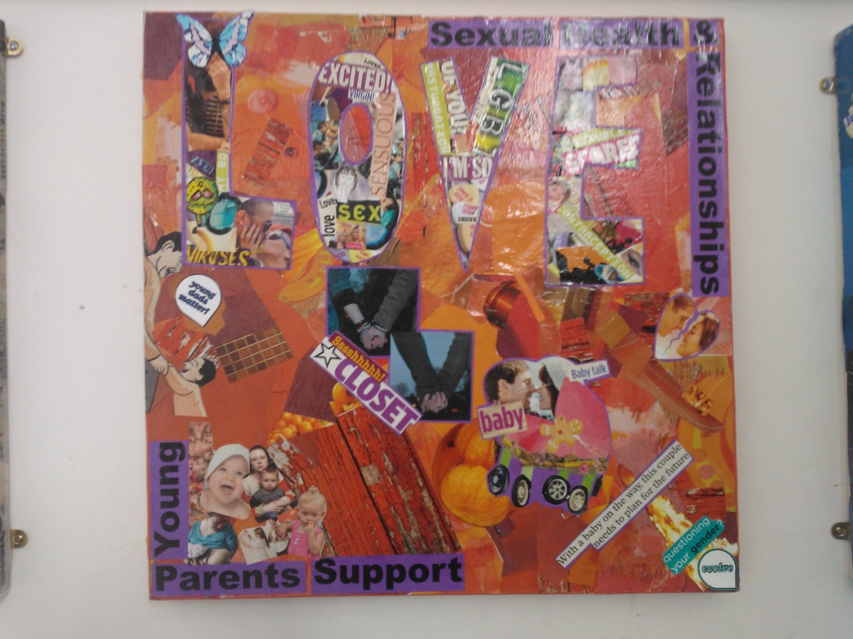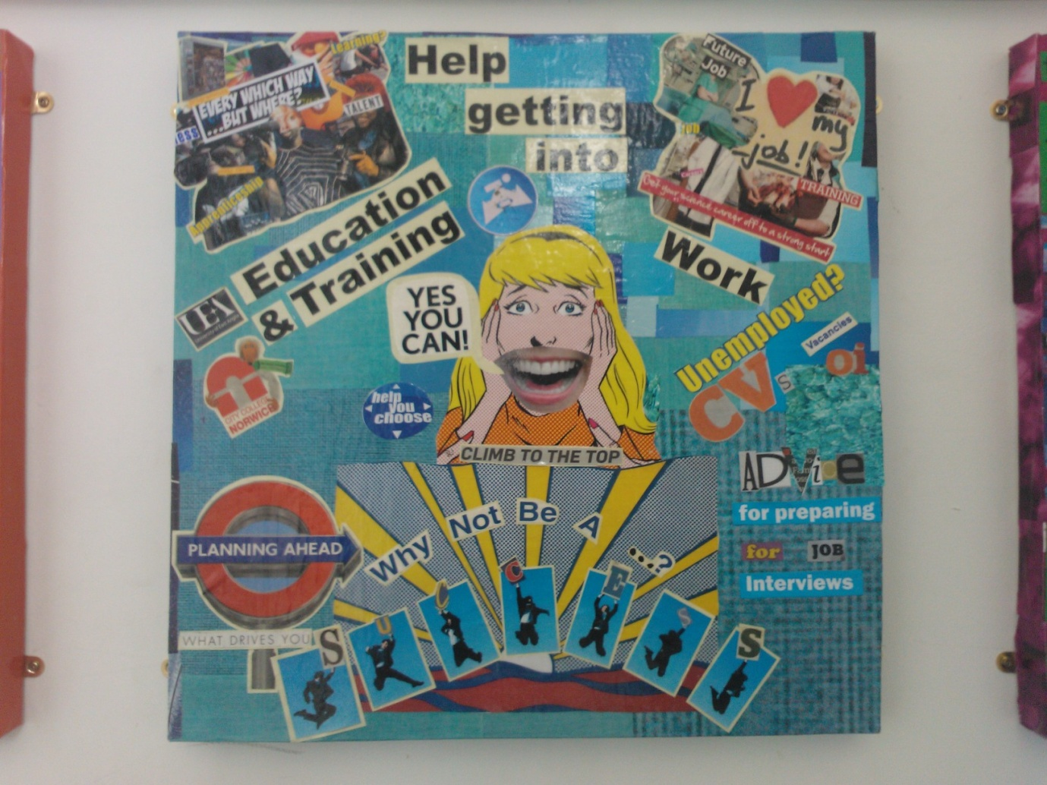

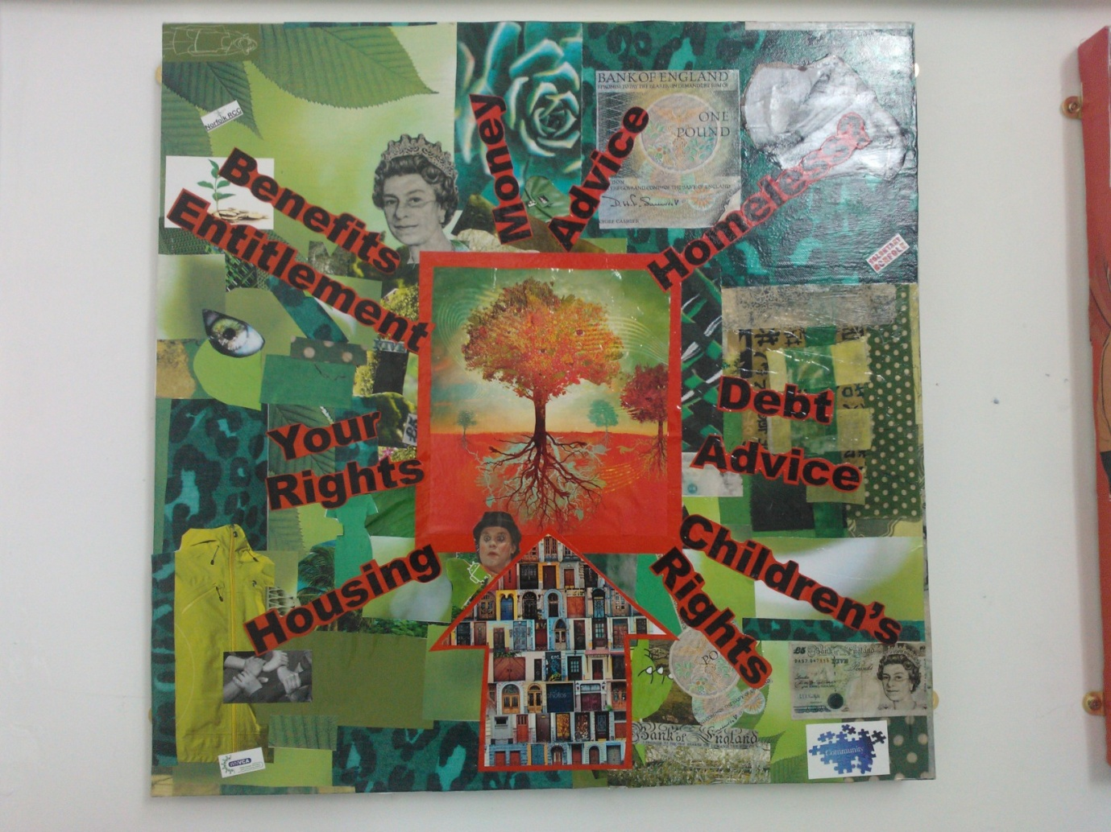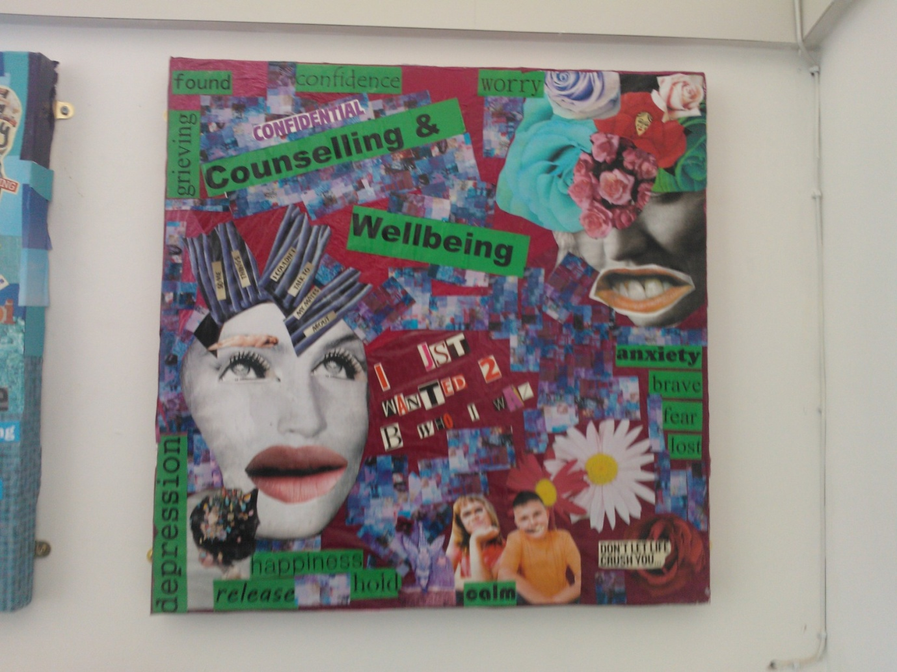

Trustee Induction Pack

2020

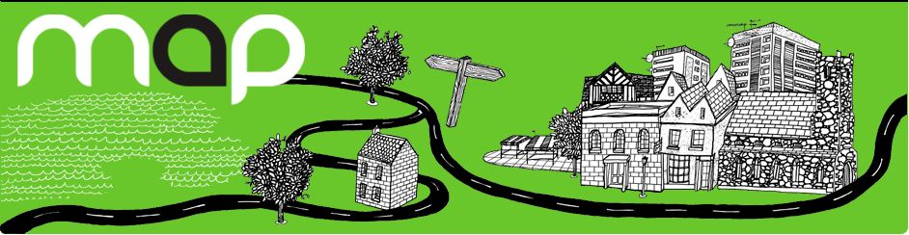

**Contents**

1. Trustee Job Advert and details of how to apply
2. An overview of MAP
   * MAP’s vision, mission and values
   * A brief history of MAP

1. Organisational structure
   * MAP organisation charts
   * MAP’s services

1. Our current Board of Trustees

1. Trustee role description

1. Individual support and guidance
2. Also available upon request

* + Trustee Declaration Form
  + Most recent minutes of Board meeting
  + MAP Financial Statement
  + MAP Strategic Plan 2019-22

. . . . for young people finding their way

**We are seeking MAP Trustees**

**Time commitment:** Minimum attendance at 4 Board meetings per annum which take place on Monday evenings at 6:00 p.m. plus an annual Trustee Away Day

Mandatory training in safeguarding

Attendance at sub-group meetings and additional away days if additional duties are taken on e.g. Trustee safeguarding lead or finance lead

**Role type:** Voluntary. Expenses will be paid for travel, etc.

**Location:** Norwich

MAP supports thousands of young people in Norfolk each year by providing free and independent advice, counselling and youth work. We have a team of around 100 staff and volunteers who are committed and passionate about providing these essential services. We are looking for individuals to join our Trustee Board to assist us with the strategic direction of the project going forward.

We’re seeking a diverse range of applications to reflect our work with a diverse range of young people. We are committed to equality, diversity and inclusion.

**We would like to hear from you if…**

You want to support our mission and become a Trustee, especially if you have a particular interest in getting involved in areas such as safeguarding, education, finance and health & safety or have a clinical background.

We’re seeking to recruit Young People as Trustees to influence our work with a diverse range of young people. If you are aged 16-30 and want to contribute your knowledge and lived experience to MAP we are very interested in hearing from you as we are looking to represent young people on our board in order to make decisions that are centred on their needs.

Prior experience of being a Trustee for a charity is not required as you will be provided with training, support and mentoring to develop your understanding of what being a Trustee means. You will need to be interested in attending meetings, considering reports and other papers.

**Our commitment to you…**

You’ll be joining a team of seven trustees, each with their own interests and expertise for you to learn from and engage with. We’re looking for fresh perspectives and new ideas to bring to the board; we will listen to your ideas and enable you to be involved in developing MAP as a service provider. Whether you’re a young person yourself who wouldn’t think of themselves as a trustee, you work in completely different sector, or just haven’t thought about being a trustee before, we’d love to hear from you.

**The role of Trustee…**

You’ll be overseeing and directing our strategic plans and helping us to meet our objectives and obligations. As a charity, we’re passionate about our values, which we’d hope you would be too. These are:

* Being Young Person Centred
* Valuing Each Individual
* Being Professional
* Working for Social Justice

It’s our mission to help all young people in Norfolk know what it is to be valued, and to ensure they have access to all the support and information to make a successful transition into adulthood. The role of Trustee is integral to this mission, and the knowledge, experiences and insight you could bring can make a huge difference to lives of young people in Norfolk now.

**I’m interested, what are the next steps…**

If you think you have the time, passion and enthusiasm to join us on our journey, we’d love to hear from you. If you’d like an informal chat about the role please email: [**HR@map.uk.net**](mailto:HR@map.uk.net) who will answer any initial questions or put you in touch with Dan Mobbs, Chief Executive for any specific questions or for a fuller overview of what being a Trustee means.

**How to apply…**

Once you have decided to submit an application to be a Trustee please email [HR@map.uk.net](mailto:HR@map.uk.net) with a cover letter (max 2 sides A4) outlining:

* Why you want to be a trustee of MAP, including why you care about our mission?
* What you would like to gain from this experience?
* What programmes or youth related activities you have previously been involved in?
* What you feel you could bring to the post based on your experience and skills, with reference to the responsibilities described in this pack.

Please also provide:

* An up-to-date CV.
* Details of two people who ‘nominate’ you to the role of Trustee who are willing to make a statement outlining your suitability. Please note, we will contact nominees before the Board meeting which is the final stage of the selection process.

**The selection process**

Applications will be reviewed and shortlisted by MAP’s Chief Executive and the chair of the board. Shortlisted applicants will be invited to attend a semi-formal interview with them.

Lastly, you will be invited to join MAP’s next general board meeting, to participate and observe. This will be your final opportunity to confirm your desire to join the board, and to sign MAP’s declaration and ethos statement in addition to the charities commission trustee eligibility declaration. Your details will then be inputted on the [**charities commission**](https://register-of-charities.charitycommission.gov.uk/charity-search/-/charity-details/4013684/charity-overview)and [**companies house**](https://find-and-update.company-information.service.gov.uk/company/05249208) databases.

Successful applicants will be required to undergo a Basic DBS check, arranged and paid for by MAP.

**Eligibility…**

The role of Trustee is overseen by The Charity Commission. In 2018, the Commission updated their guidelines on what might disqualify a person from becoming a Trustee. To find out more, click [**here**](https://www.gov.uk/guidance/automatic-disqualification-rules-for-charity-trustees-and-charity-senior-positions) to view the Government’s guide for individuals.



**MAP’s vision, mission and values**

MAP’s **vision** is that all young people will know what it is to be valued, and that they will have the support and information they need to make a successful transition into adulthood.

When I approached **MAP**

I was at rock bottom. I had seen counsellors in other organisations before but never really benefitted from their help. In the first session at **MAP** I felt the **counsellor truly understood my situation,** how much it meant to me to access that help, and how hard it was for me to be **giving counselling another chance.**

My sessions have become somewhere I can release feelings and thoughts in a **safe environment**. I have been able to deal with issues from my past, accept the parts of my life that I cannot change, and move on from it.

I’m now happy, and loving life. Counselling through **MAP** has helped to achieve a very **steady and positive approach**; something I never thought would happen. I wouldn’t be in such a good

place today without **MAP**’s help.

**Young Person, 21**

Our **mission** is that all young people have the right to access the quality information, advice, counselling and support they need for their holistic development. This encompasses physical, social and emotional well-being.

We apply our **values** to young people, staff, volunteers, partner agencies and everyone else we work with.

MAP’s values are:

**Being Young Person Centred**

We believe in being flexible and offering choice. We listen to and are led by a young person’s holistic needs. We advocate for a young person’s rights. We involve young people. We develop new and innovative services to ensure we meet the changing needs of young people.

**Valuing Each Individual**

MAP respects and celebrates the differences between people. We believe that each person has their own individual needs, strengths and unique experiences. We want people to express who they are, to be authentic. We value trust. We also encourage staff and volunteers to work with passion and commitment.

**Being Professional**

We believe that young people should get the best services at the highest quality. We believe our staff and volunteers should be well trained and supported. We believe all our services should be based on best and reflective practice with proven outcomes. We believe in being realistic and consistent.

**Working for Social Justice**

We believe that we have a wider social responsibility within our community. We work to inform local and national health and social policy. We believe in campaigning on behalf of disadvantaged and marginalised groups of young people. We believe in promoting rights and responsibilities and challenging prejudice and oppression.

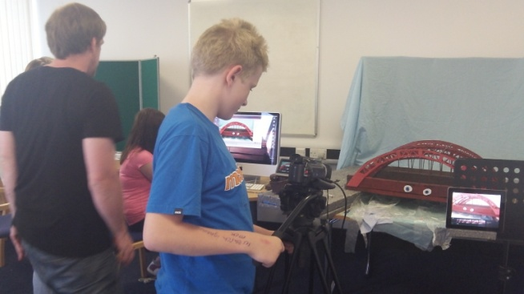



**A Brief History of MAP**

**My son** was having real difficulty with some **major changes in his life**. As a mother I found it difficult coping, but **knowing there was someone at MAP there** **for him** made all the difference. He is now doing really well, and has become a **wonderful, caring young man.**

It could so easily have gone the other way.

**Parent**

“

MAP’s history began 300 years ago with Alderman John Risebrow, who took his oath as Sheriff in Norwich in 1704.

In his will of 1723, he left his estate and the proceeds for the wellbeing of young people in the Mancroft ward, originally via a charity school

*“...for the physical, mental and spiritual education and well-being of young people within the ecclesiastical parish of St Peter Mancroft”.*

Following the sale of land at the heart of the bequest in the late 1980s a decision was made by the Risebrow Trustees to use the money in a way fitting with John Risebrow’s original endowment. After consultation with Norfolk Youth and Community Service they set up an information and advice centre for young people.

**MAP opened its doors in 1991 as Norfolk’s first Youth Information, Advice and Counselling centre. Then, as now, we set out to offer all our services under one roof, and give young people time and space to access the best kind of help for them at the best time.**

Demand for our services has increased over twenty years, and the size of MAP has grown in Norwich and across Norfolk. Currently, there are 83 staff and five volunteers who work in a holistic way with each young person’s needs, to build mutual trust and respect, offer consistent support and advice, and provide a service in a way that best suits each young person as they find their way.

Over the last year we worked with over 4,000 young people.

**MAP’s Services**

MAP is here for young people. We are **Advisers**, **Counsellors** and **Youth Workers** who work together to provide the best help we can in a way that makes sense to young people. We also provide **education and training** for young people, parents, carers and other workers. We work from our centres in Norwich and Great Yarmouth, and from other places around Norfolk including schools, health centres and youth centres.



I got involved with **MAP** when I became homeless as I had to **flee my home** in Suffolk. Through the past year **MAP** has helped me find a home, sort out my benefits, and get in touch with mental health **services in my area**. MAP helped me discover myself and has helped keep me alive when things have been bad.

Without **MAP** I don’t know what I’d have done or where I would be. I think it is **the most helpful agency for young people** because they cover all the subject related to our age group. **MAP** workers, with their friendly, laid back approach, make it **easier to talk to them and trust them**.

The help and attention I’ve had from MAP is beyond anything I have received before, or since, and has helped me see that **everyone is worth it**.

**Young Person, 18**

**Advice Services**

The Advice Services Team provides young people with information, advice, support and advocacy on practical issues such as benefits and **welfare** reform, **employment, education and training**, **money and debt**, **housing and homelessness**, **sexual health and relationships**, **being a parent**, **family relationships** and finding **things to do**. The Advice Services Team holds the [**Advice Quality Standard (AQS) quality mark**](http://www.advicequalitystandard.org.uk/) for advice and casework.

**Therapeutic Services**

Our Counsellors and Youth Mental Health Workers work with young people to overcome any personal problems they may be having. We believe young people are unique, deserve to be respected, and can be at their best when given the space and support that feels right for them. A relationship with a Counsellor can help a young person to understand themselves, see problems more clearly and be empowered to make choices about their lives. Counselling is different for everyone: it can be about resolving specific problems, making difficult decisions, coping with a crisis, understanding oneself better or improving relationships with others. Whatever a young person’s experience we provide counselling that meets their needs. We make sure our counselling is of the highest standards: all our Counsellors have professional counselling or psychotherapy qualifications accredited with the BACP (British Association for Counselling and Psychotherapy) or UKCP (United Kingdom Council for Psychotherapy), and are professionally supervised.

**Youth Work Services**

### Our Youth Workers provide young people with **opportunities to learn new things and meet new people. They work with groups of young people to help them become more involved with their community and have their say, and with schools to deliver education programmes.** Youth work at MAP is all about informal learning and personal development so young people can learn more about themselves, others, and the community they live in. Our youth work programmes offer opportunities for young people to develop a sense of belonging and aspiration, and provide them with opportunities to realise their potential. We offer a wide range of activities which include **day trips, residential weekends, workshops,** and **courses to gain qualifications**, based on what young people tell us they want. We support young people to make a difference in their community through youth advisory boards, campaigning and activism.

**What happens where?**

**Norwich**

The **Norwich Drop-In Centre is open every day from 1.30 to 5.30pm** and is where young people can come for advice without having to make an appointment. Free phones, fax and internet access are available for young people to use. Tea and coffee is also free. The Drop-In Centre is warm, comfortable and friendly.

**Great Yarmouth**

**Youth Workers, Counsellors,** and **Advice Workers** in **Great Yarmouth** are able to give support and advice about practical things that might affect young people. The team can work with young people to help them find a job, education and training, and access useful, interesting, and fun things to do. On **Mondays, Wednesdays and Fridays between 1.30pm and 5.30pm**, young people aged between 11 and 25 can **drop in for advice**.  They can see an Advice Worker, a Youth Worker and a male or female Sexual Health Worker **without an appointment**, and use our phones and access the internet for free.

**North Norfolk**

Our Counsellors in North Norfolk are based in **The Atrium** on the **North Walsham High School** site, but they can travel to meet young people at a place that is convenient for them. Our youth workers have started work with young people in **Cromer, Sheringham, Mundesley, and Stalham**, to create four youth hubs encouraging young people’s participation within their communities.

**South Norfolk**

In South Norfolk our Counsellors are based in **Attleborough,** but they can travel to meet young people closer to where they live.

**West Norfolk**

Advice Workers, Counsellors and Youth Workers in Kings Lynn are able to give support and advice about practical things that might affect young people. The team can work with young people to help them find a job, education and training and access useful, interesting, and fun things to do. On Tuesdays and Thursdays between 1.30pm and 5.30pm, young people aged between 11 and 25 can drop in for advice. Our Counsellors in West Norfolk can also travel to meet young people closer to where they live.

**Remote delivery of our services**

Since the Covid-19 pandemic commenced we have mobilised our services and can connect with even more young people across Norfolk via communication platforms such as Zoom. We seek to provide our services in line with young peoples’ needs and preferences so they feel comfortable engaging with us their way.

**MAP’s current Board of Trustees**

**Caroline Billings (Chair)** is a Partner at Norwich solicitors Hatch Brenner. Caroline specialises in family law, particularly protecting the rights of the vulnerable.

**Kate Blake-Holmes** is a qualified social worker and is currently a lecturer in Social Work at the UEA.

**Karen Buchanan** is Course Leader in Level 2 Creative Media at City College Norwich and a trustee of the Sir John Hurt Film Trust. A devout Norwich City fan, she launched FourFourTwo football magazine in 1994, reported for BBC's Match of the Day at France '98 and co-wrote Norwich legend Iwan Roberts' best-selling diary All I Want For Christmas. She has worked all over the world and is passionate about empowering young people to realise how amazing they are, travelling and Marmite.

**Edward Carter** is the Vicar at St Peter Mancroft, the church that set up MAP. He has been an ordained minister in the Church of England since 1997, and before that worked for small companies. His interests include board games and amateur operatics.

**Isobel McQuire** is a student at the UEA studying Global Development with Anthropology and has recently joined a university led initiative called Take Five, to encourage students to take a break and focus on their mental well-being.

**Gita Prasad** is Deputy Director of Business and Partnerships at the East of England Ambulance Services Trust and has worked in the NHS and local government in adult and children’s services roles for 16 years. Gita has a special interest in children who have suffered harm as a result of domestic or sexual abuse and violence. She is passionate about reducing inequalities and about music, former chair of Viva Voce Singers.

**David Roe** is a HR professional, focussing on Legal Recruitment of Trainee Solicitors. He previously worked at MAP in an HR capacity, where he gained a real insight into the valuable work that MAP provides in the local community for young people. His interests include snow sports, football, cricket and cooking.

**Lucy Spratling** is a psychology graduate from UEA. Her interest in this topic mainly focuses on mental health, development and neurodevelopmental disorders, especially in children and young people. She currently works as a support worker in Norwich.

**MAP’s Senior Management Team**

**Dan Mobbs** is MAP’s Chief Executive. Dan has worked in the voluntary sector for over 20 years since graduating in psychology. He has worked in the field of mental health, homelessness and substance misuse; though started out as a play leader at his local council play scheme. He has been in leadership positions for more than 15 years. He is also the elected chair of the Norfolk Voluntary Sector Forum for Children and Young People and a trustee of Youth Access.

**Darren Cox** is MAP’s Director of Operations and was appointed in January 2022. For most of Darren’s working life he has held roles which impact young people, these roles include delivering sports activities within schools, working for Norwich City as a football coach, lecturing for City College Norwich, creating and delivering his own college to support disengaged learners and assessing apprenticeships. More recently leading within a Suffolk based Charity as their director of education, creating a diverse portfolio of education programs and curriculums.

**Tonia Mihill** is MAP’s Head of Therapeutic Services. Tonia originally studied History and Politics, and subsequently gained a PGCE in Secondary History teaching and a Diploma of Higher Education in Counselling and Therapeutic Care.  As a trainer she specialises in Race Awareness and Diversity issues and set up the first Norfolk Black History Month programme in 2003. Continuing a longstanding involvement in global justice issues, Tonia is currently a Trustee of PADEAP – a Pan African Development Education charity.

**Yolly Southgate** is MAP’s Head of Advice Services. After graduating in Mathematics & Philosophy, Yolly wanted to gain some real world experience and so trained as an adviser with Citizens Advice. Yolly specialised in Debt & Benefits Advice before going onto lead teams of advisers at Citizens Advice & Equal Lives. Yolly was appointed to the position of Head of Advice in August 2021.

**Mal Cunningham** is MAP’s Head of Youth Work Services and was appointed in January 2024. Mal has a wealth of experience in youth work and has recently returned to the UK after spending the last four years working for the Jersey Youth Service.

**Justina Duggan** has worked for MAP for over 20 years and is our Finance Manager. Justina is a qualified accountant, ensuring budgets are being spent wisely and regularly forecasts the financial horizon for the charity in a challenging environment of various funding streams and timelines.

**Jodie Butler** is MAP’s Human Resources Manager. Jodie has over 19 years’ experience in HR in the public sector working for a District Council and joined MAP in 2020 for her first voluntary sector position. A graduate and a member of the Chartered Institute of Professional Development, Jodie has a passion and drive to continue to make MAP a great place to work with a strong emphasis on employee engagement and wellbeing. Jodie is on the school PTA for the school her two son’s attend.

**Morgan Pickard** has recently been promoted to the role of Development Manager and is tasked with generating new funding and maintaining good relationship with existing funders. Morgan has worked within the fundraising field for over 6 years’ including roles as a Development Manager for national charities and supporting and managing their local fundraisers and volunteers.

**Trustee of MAP**

# Role description and person specification

## **Volunteer role description**

To meet the following statutory duties:

* To contribute actively to the board of trustees’ role in giving firm strategic direction to MAP, setting overall policy, defining goals and setting targets and evaluating performance against agreed targets.
* To ensure that MAP complies with its governing document, charity law, and any other relevant legislation or regulations.
* To ensure that MAP pursues its objects as defined in its governing document.
* To ensure MAP applies its resources exclusively in pursuance of its objects.
* To safeguard the good name and values of MAP.
* To ensure the effective and efficient administration of MAP.
* To ensure the financial stability of MAP.
* To protect and manage the property of MAP and ensure the proper investment of MAP funds.
* To appoint the director/s and monitor his/her performance.

**Other duties**

In addition to the above statutory duties each trustee should use any specific skills, knowledge or experience they have to help the board of trustees reach sound decisions. This may involve:

* Scrutinising board papers
* Leading discussions
* Focusing on key issues
* Providing guidance on new initiatives
* Other issues in which the trustee has special expertise

## **Person specification**

* Commitment to MAP and its work
* Willingness to devote the necessary time and effort
* Strategic vision
* Independent judgement
* Ability to think creatively
* Willingness to speak their mind
* Understanding and acceptance of the legal duties, responsibilities and liabilities of trusteeship
* Ability to work effectively as a member of a team
* Behaviour evident of Nolan’s seven principles of public life; selflessness, integrity, objectivity, accountability, openness, honesty and leadership
* Commitment to continuing personal and professional development in the role.

**Individual support and guidance**

## **Induction and mentoring support**

As a new trustee, you will be encouraged to spend time familiarising yourself with the charity, visiting our drop-in centres, meeting our senior management team, observing youth work activities.

A nominated member of the board will be assigned as your mentor, to help prepare you for your first board meetings, and to debrief about your experience after each meeting. This mentoring support will be in place for the first year of your appointment.

## **Expenses**

All travel and other reasonable expenses incurred during the course of your activities as a trustee of MAP may be reimbursed, including participation in quarterly general meetings and attendance at MAP events or activities.

**Additional Information**

The following documents are also also available upon request:

* + Trustee Declaration Form
  + Most recent minutes of Board meeting
  + MAP Financial Statement
  + MAP Strategic Plan 2022-25

***Thank you for your interest in becoming a Trustee of MAP!***